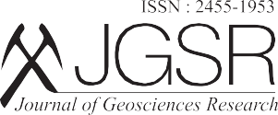
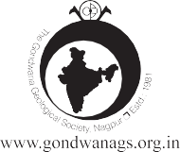
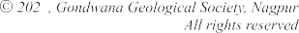Vol. 8, No.2, July, 2023, pp. 160-163
Research Article
3

Principal Component Analysis to Assess the Heavy Metal Enrichment in the Urban Soils of Kabini Basin: Emerging Concerns
Himanshi Guptaa,b, Appukuttanpillai Krishnakumara*and Krishnan Anoop Krishnana

aNational Centre for Earth Sciences Studies, Ministry of Earth Sciences, Govt. of India, Akkulam, Thiruvananthapuram-695011(KL), India
bCochin University of Science and Technology, Kochi-682022, (KL), India (*Corresponding author, E-mail: drakrishnakumar@gmail.com)

Abstract

Heavy metal enrichment in urban soils demarcates a major ecological concern. The emerging industries, settlements and agricultural lands in bank of Kabini River resulted in prominent changes in water and soil geochemistry. In present work, a total of 20 soil samples from Kabini Basin have been checked for trace metals concentration and assessed following multivariate statistical approach. The PCA has been conducted to characterize the trace metals as per the common source of origin. The factors distinguished the heavy metals into 3 components with overall variance of 82.53%. Higher loading of various heavy metals indicates natural and anthropogenic interferences in soil. The baseline data generated from the present study provides the insight over the concentration of heavy metals, which would further be helpful in conservation and management of soil resources of the basin.

Keywords: Heavy Metal, PCA, Urban Soils, Kabini Basin

