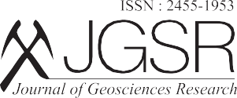
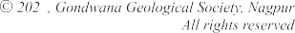Vol. 8, No.2, July, 2023, pp. 179-183
Research Article
3

Relationship of Modern Diatoms with Lake Acidification and Water Quality in Nsonji Lake of Nagaland, North-East India
Zayieno Kere1, Samaya S. Humane2* and Shaik Mohammad Hussain1

1Department of Geology, University of Madras, Chennai-600025(TN), India
2P.G. Department of Geology, RTM Nagpur University, Nagpur-440001(MS), India (*Corresponding author, E-mail: samaya.humane@gmail.com)

Abstract

Understanding the relationship of diatoms and water quality is of paramount importance to link it to Holocene Climate Change. Since diatoms are extremely sensitive to environmental changes, they are the obvious choice to study diatom inferred water quality and climate changes. Therefore, sediment samples along with water samples were collected during pre monsoon seasons from the Nsonji Lake of the Nagaland, India to establish the relationship between the diatom and water quality. The Nsonji Lake has circum-neutral pH (around 7) indicating gradual degradation of organic matter leading to acidification of the lake. The surface sediments of the Nsonji Lake revealed the dominance of Discostella stelligera, Achnanthidium sp., Navicula cryptocephala, Navicula radiosa and Nitzschia palea. These diatom species could be used to unravel the acidification history of lake caused by natural and anthropogenic activities. Understanding the past climate dynamics need modern analogue in order to evaluate the important processes relative to Earth's history and built future scenario.

Keywords: Diatoms, Water Quality, Acidification, pH, Organic Matter, Nsonji Lake, Nagaland

